**Lab 5**

**Task: Implement all the topics/functions of OpenCV**

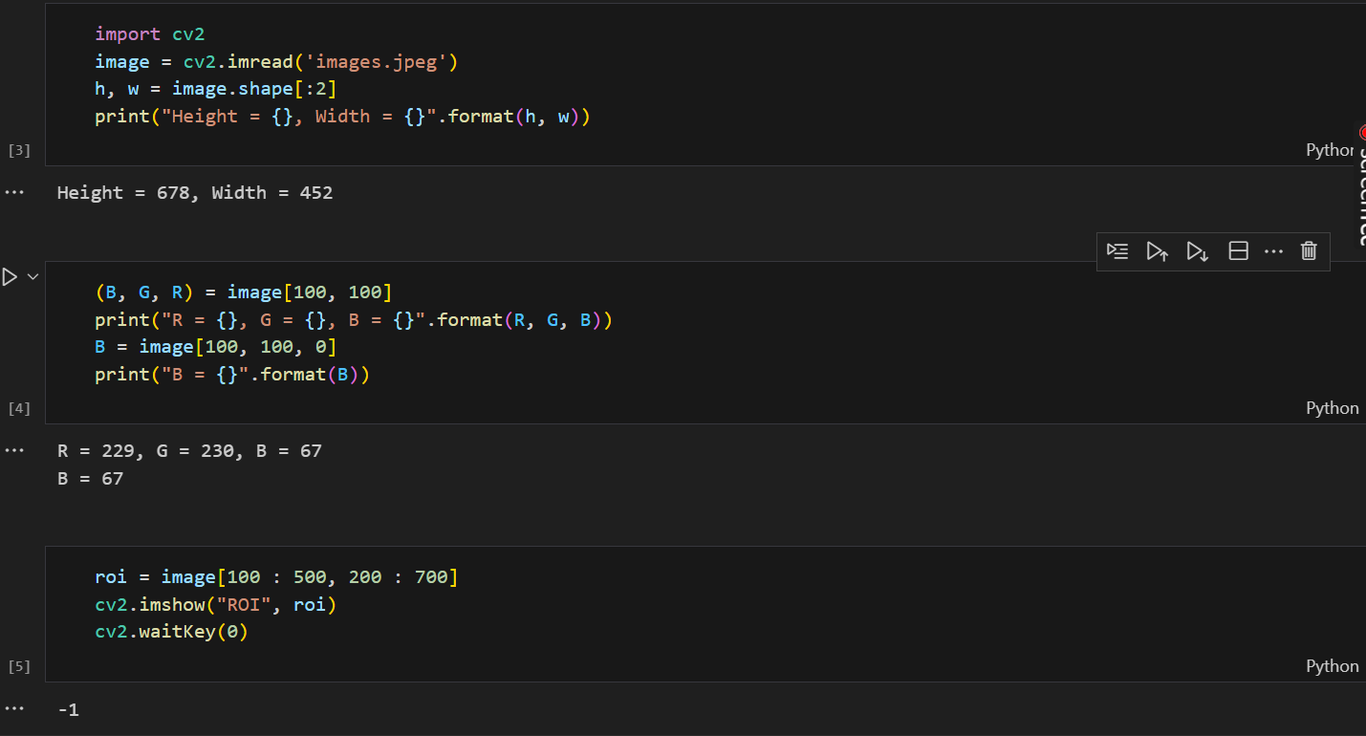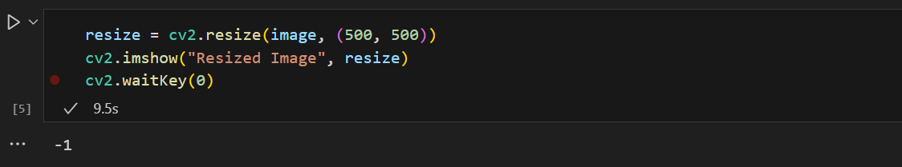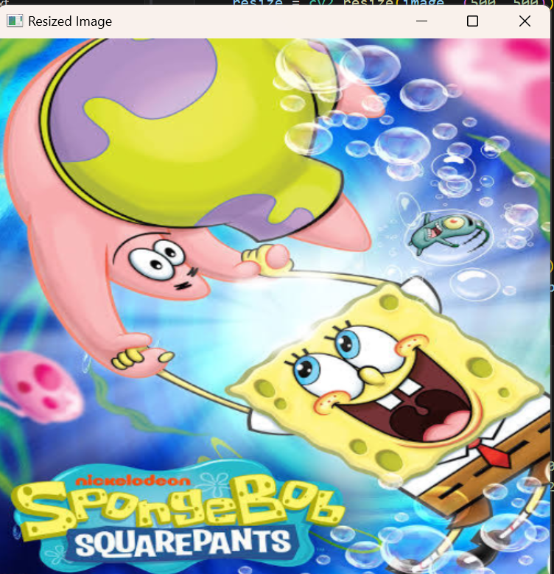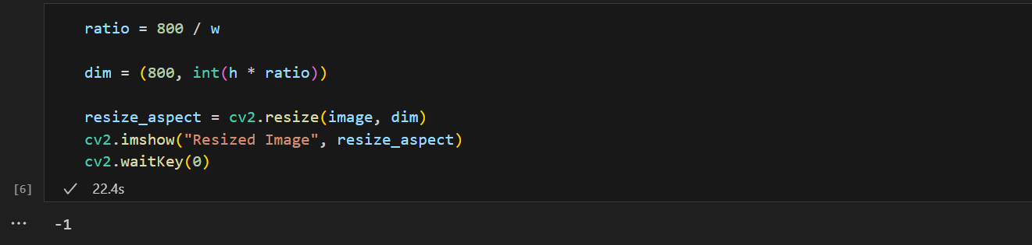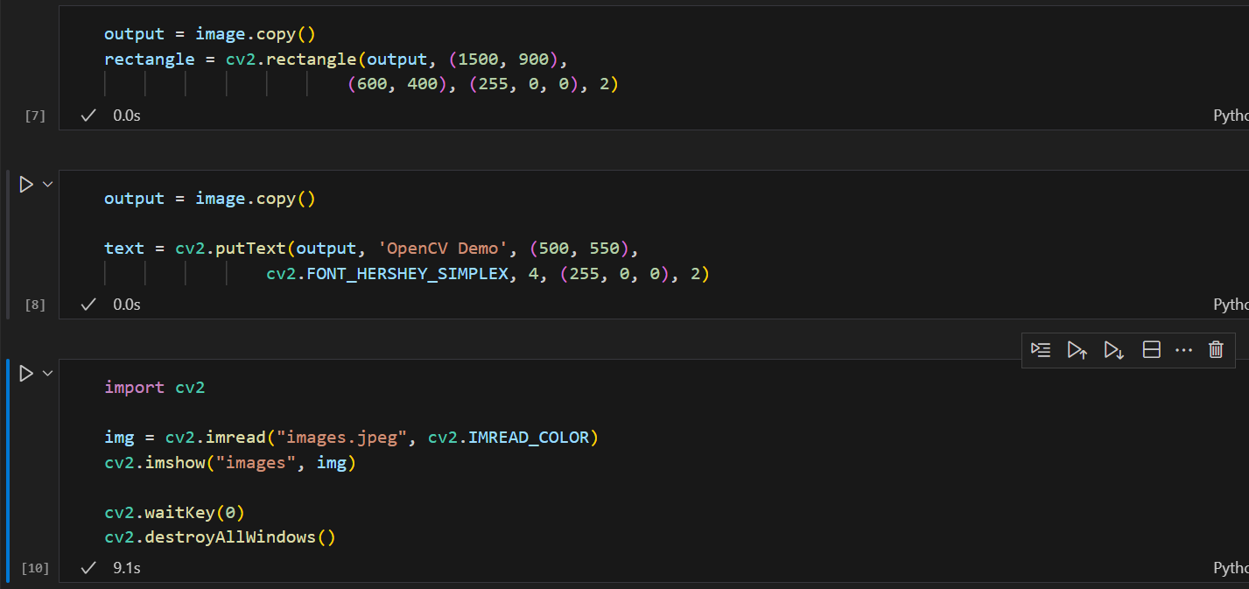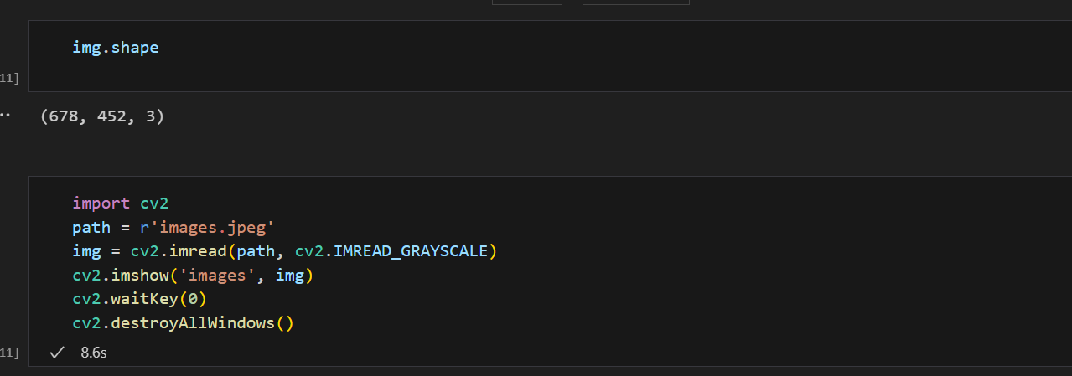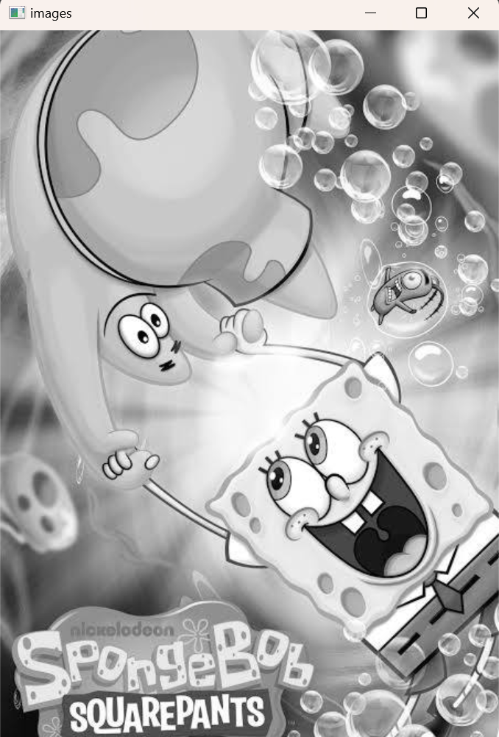

import cv2

image = cv2.imread('images.jpeg')

cv2.imshow('Image Window', image)

cv2.waitKey(0)

cv2.destroyAllWindows()

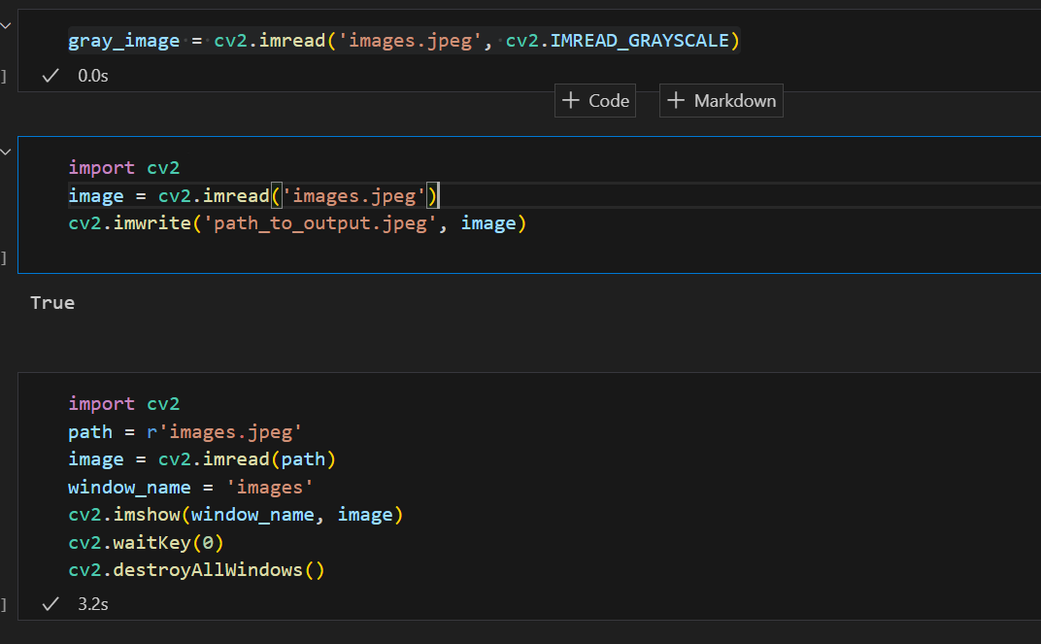

import cv2

image = cv2.imread('images.jpeg')

B, G, R = cv2.split(image)

cv2.imshow("original", image)

cv2.waitKey(0)

cv2.imshow("blue", B)

cv2.waitKey(0)

cv2.imshow("Green", G)

cv2.waitKey(0)

cv2.imshow("red", R)

cv2.waitKey(0)

cv2.destroyAllWindows()

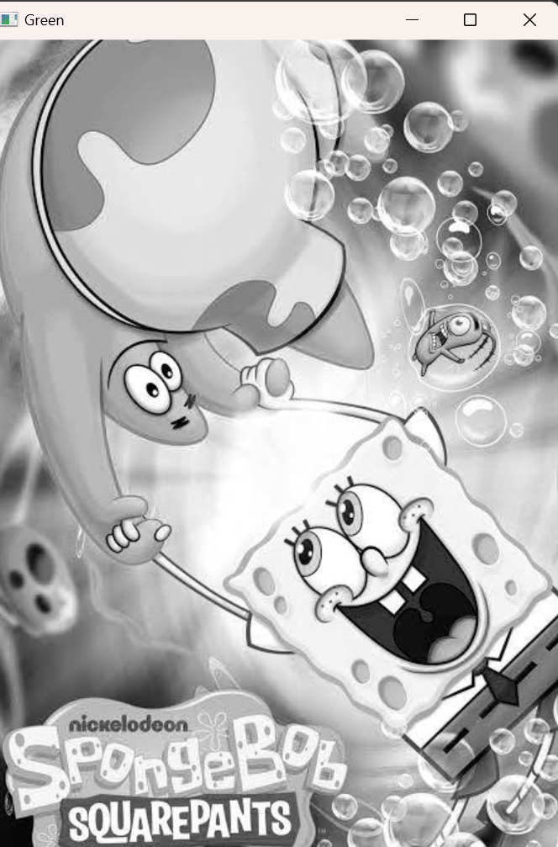



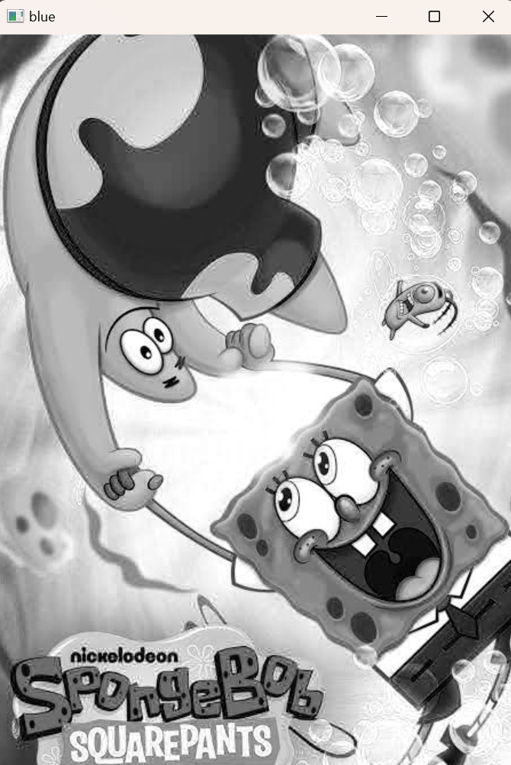

import cv2

import numpy as np

image1 = cv2.imread('input1.jpg')

image2 = cv2.imread('input2.jpg')

weightedSum = cv2.addWeighted(image1, 0.5, image2, 0.4, 0)

cv2.imshow('Weighted Image', weightedSum)

if cv2.waitKey(0) & 0xff == 27:

    cv2.destroyAllWindows()

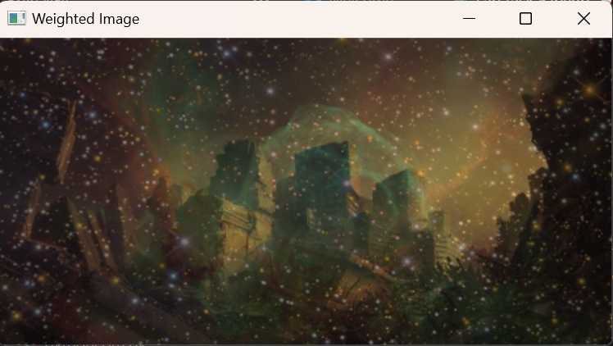

import cv2

import numpy as np

image1 = cv2.imread('input1.jpg')

image2 = cv2.imread('input2.jpg')

sub = cv2.subtract(image1, image2)

cv2.imshow('Subtracted Image', sub)

if cv2.waitKey(0) & 0xff == 27:

    cv2.destroyAllWindows()

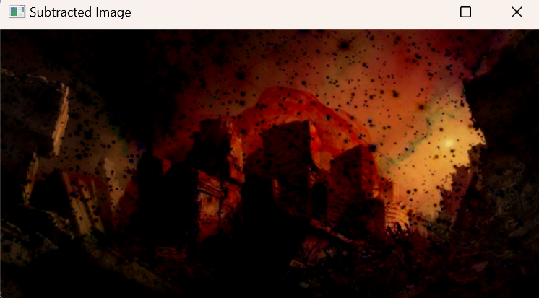

import cv2

import numpy as np

img1 = cv2.imread('input1.jpg')

img2 = cv2.imread('input2.jpg')

dest_and = cv2.bitwise_and(img2, img1, mask = None)

cv2.imshow('Bitwise And', dest_and)

if cv2.waitKey(0) & 0xff == 27:

    cv2.destroyAllWindows()

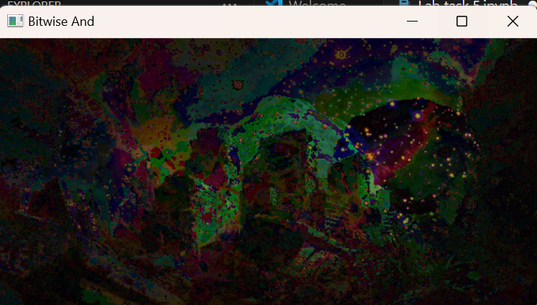

import cv2

import numpy as np

img1 = cv2.imread('input1.jpg')

img2 = cv2.imread('input2.jpg')

dest_or = cv2.bitwise_or(img2, img1, mask = None)

cv2.imshow('Bitwise OR', dest_or)

if cv2.waitKey(0) & 0xff == 27:

    cv2.destroyAllWindows()

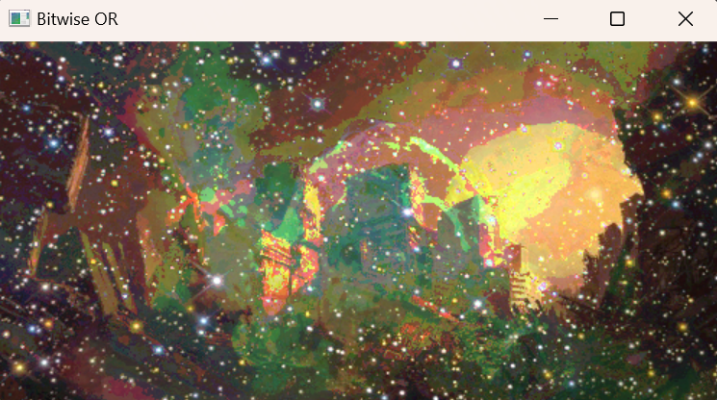

import cv2

import numpy as np

img1 = cv2.imread('input1.jpg')

img2 = cv2.imread('input2.jpg')

dest_xor = cv2.bitwise_xor(img1, img2, mask = None)

cv2.imshow('Bitwise XOR', dest_xor)

if cv2.waitKey(0) & 0xff == 27:

    cv2.destroyAllWindows()

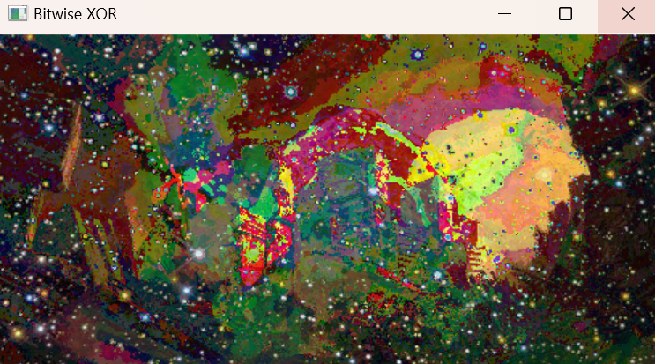

import cv2

import numpy as np

img1 = cv2.imread('input1.jpg')

img2 = cv2.imread('input2.jpg')

dest_not1 = cv2.bitwise_not(img1, mask = None)

dest_not2 = cv2.bitwise_not(img2, mask = None)

cv2.imshow('Bitwise NOT on image 1', dest_not1)

cv2.imshow('Bitwise NOT on image 2', dest_not2)

if cv2.waitKey(0) & 0xff == 27:

    cv2.destroyAllWindows()

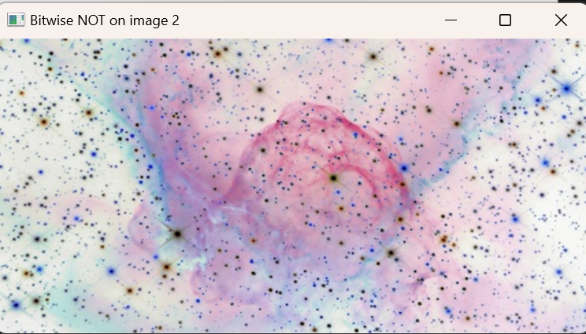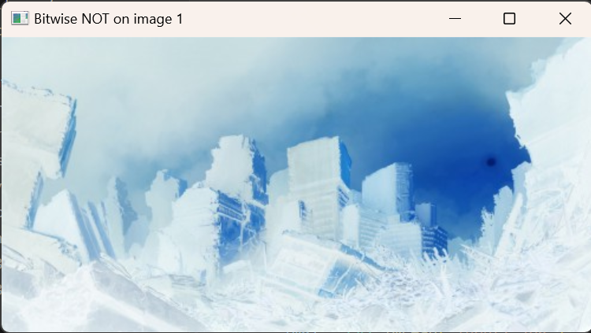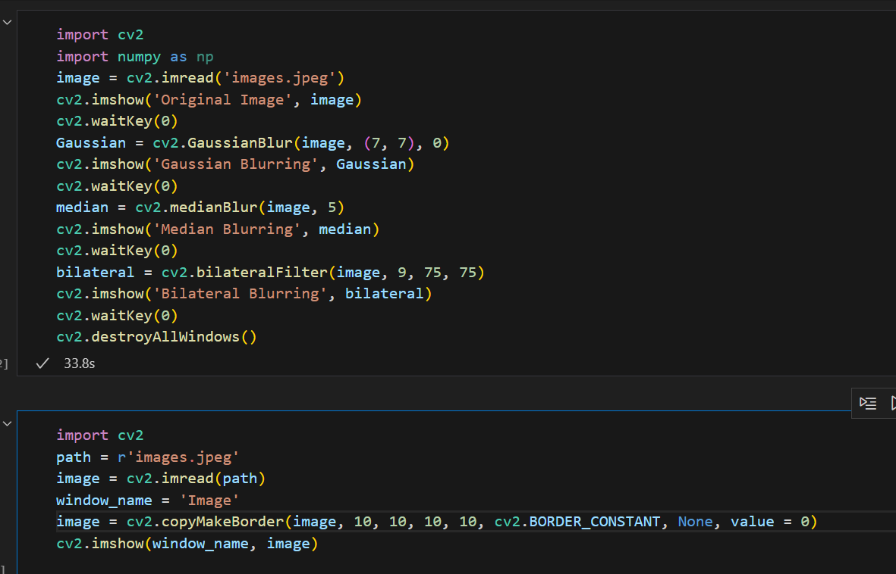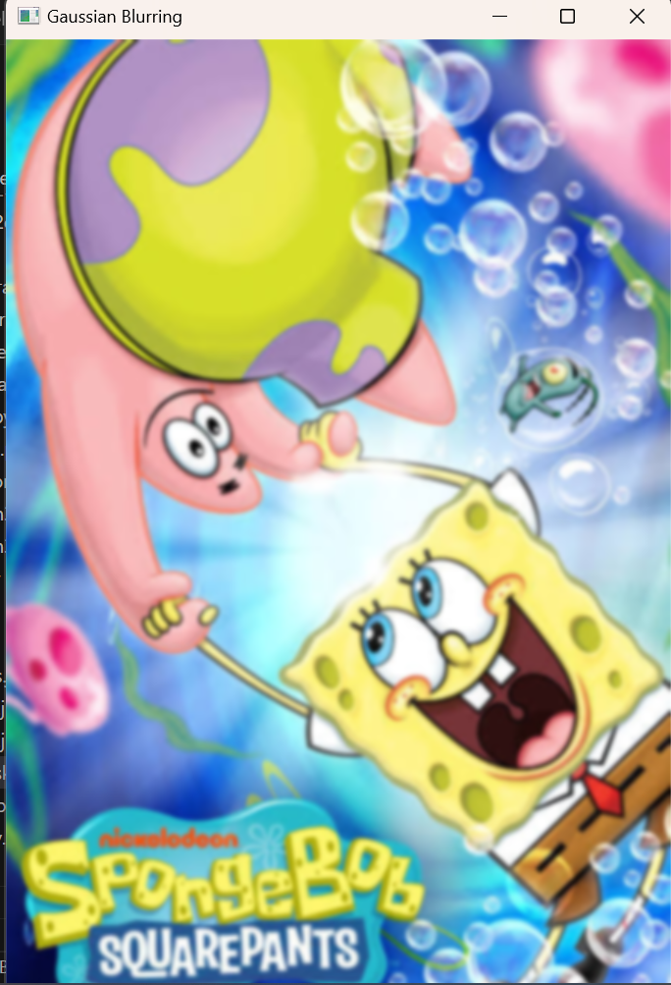

import cv2

image = cv2.imread('images.jpeg')

cv2.imshow('Original', image)

cv2.waitKey(0)

gray_image = cv2.cvtColor(image, cv2.COLOR_BGR2GRAY)

cv2.imshow('Grayscale', gray_image)

cv2.waitKey(0)

cv2.destroyAllWindows()

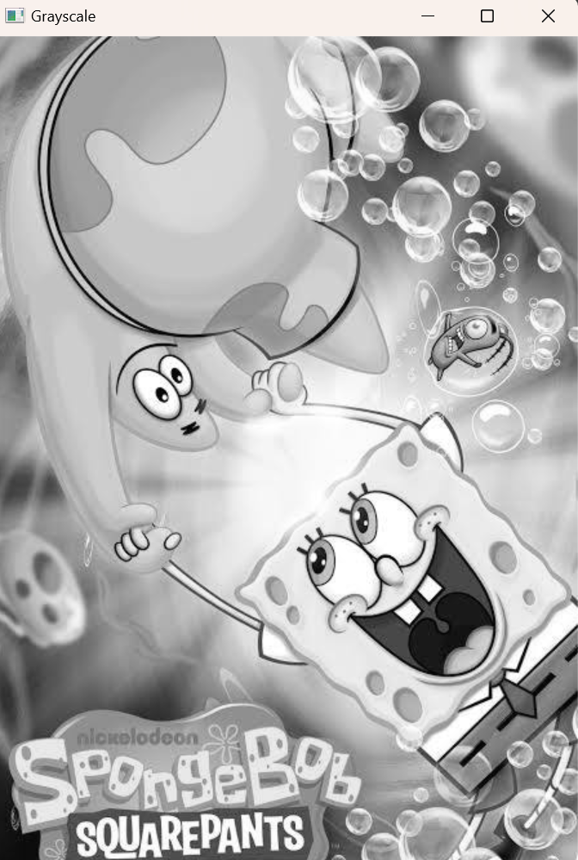

import cv2

import numpy as np

import matplotlib.pyplot as plt

image = cv2.imread('images.jpeg')

image_rgb = cv2.cvtColor(image, cv2.COLOR_BGR2RGB)

scale_factor_1 = 3.0

scale_factor_2 = 1/3.0

height, width = image_rgb.shape[:2]

new_height = int(height * scale_factor_1)

new_width = int(width * scale_factor_1)

zoomed_image = cv2.resize(src =image_rgb,

                          dsize=(new_width, new_height),

                          interpolation=cv2.INTER_CUBIC)

new_height1 = int(height * scale_factor_2)

new_width1 = int(width * scale_factor_2)

scaled_image = cv2.resize(src= image_rgb,

                          dsize =(new_width1, new_height1),

                          interpolation=cv2.INTER_AREA)

fig, axs = plt.subplots(1, 3, figsize=(10, 4))

axs[0].imshow(image_rgb)

axs[0].set_title('Original Image Shape:'+str(image_rgb.shape))

axs[1].imshow(zoomed_image)

axs[1].set_title('Zoomed Image Shape:'+str(zoomed_image.shape))

axs[2].imshow(scaled_image)

axs[2].set_title('Scaled Image Shape:'+str(scaled_image.shape))

for ax in axs:

    ax.set_xticks([])

    ax.set_yticks([])

plt.tight_layout()

plt.show()

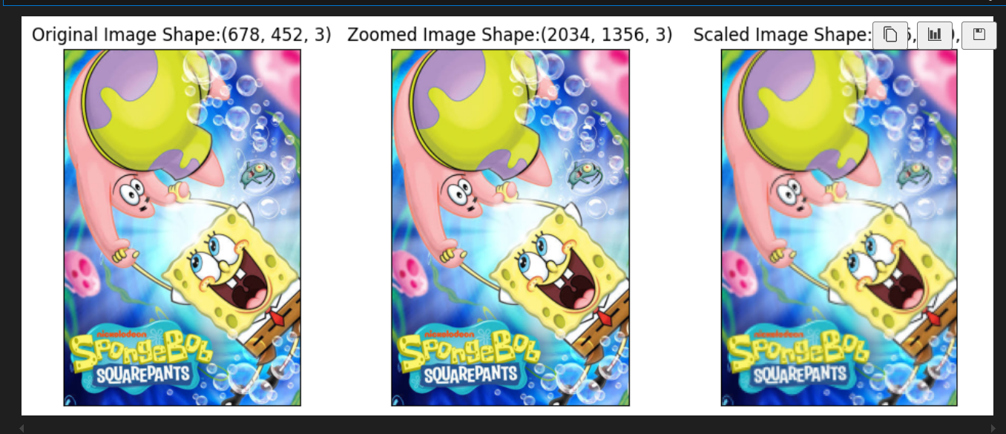

import cv2

import matplotlib.pyplot as plt

img = cv2.imread('images.jpeg')

image_rgb = cv2.cvtColor(img, cv2.COLOR_BGR2RGB)

center = (image_rgb.shape[1] // 2, image_rgb.shape[0] // 2)

angle = 30

scale = 1

rotation_matrix = cv2.getRotationMatrix2D(center, angle, scale)

rotated_image = cv2.warpAffine(image_rgb, rotation_matrix, (img.shape[1], img.shape[0]))

fig, axs = plt.subplots(1, 2, figsize=(7, 4))

axs[0].imshow(image_rgb)

axs[0].set_title('Original Image')

axs[1].imshow(rotated_image)

axs[1].set_title('Image Rotation')

for ax in axs:

    ax.set_xticks([])

    ax.set_yticks([])

plt.tight_layout()

plt.show()

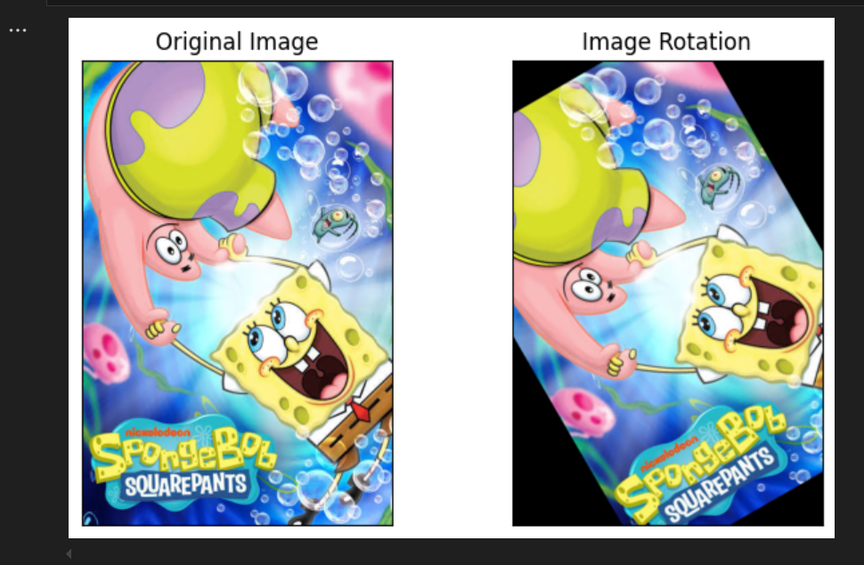

import cv2

import matplotlib.pyplot as plt

img = cv2.imread('images.jpeg')

image_rgb = cv2.cvtColor(img, cv2.COLOR_BGR2RGB)

width = image_rgb.shape[1]

height = image_rgb.shape[0]

tx = 100

ty = 70

translation_matrix = np.array([[1, 0, tx], [0, 1, ty]], dtype=np.float32)

translated_image = cv2.warpAffine(image_rgb, translation_matrix, (width, height))

fig, axs = plt.subplots(1, 2, figsize=(7, 4))

axs[0].imshow(image_rgb)

axs[0].set_title('Original Image')

axs[1].imshow(translated_image)

axs[1].set_title('Image Translation')

for ax in axs:

    ax.set_xticks([])

    ax.set_yticks([])

plt.tight_layout()

plt.show()

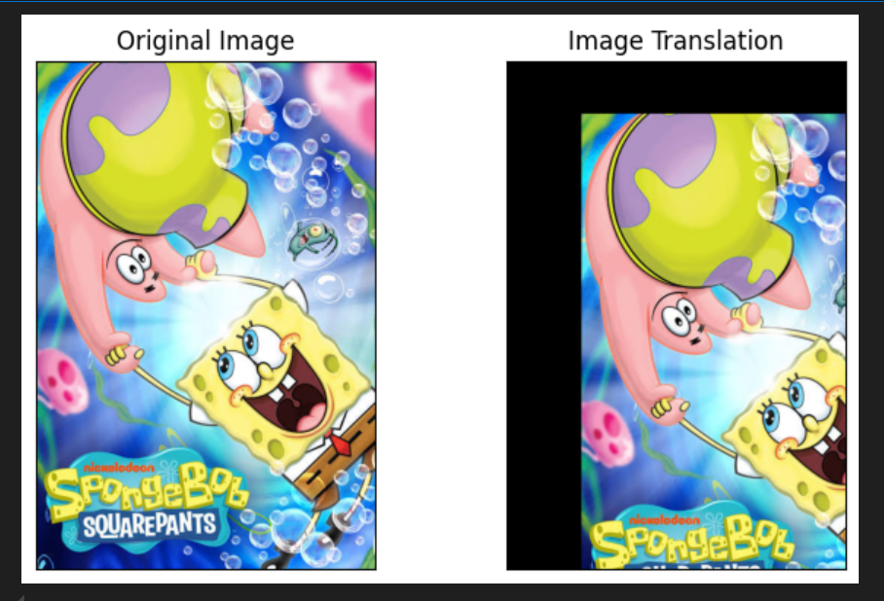

import cv2

import numpy as np

import matplotlib.pyplot as plt

image = cv2.imread('images.jpeg')

image_rgb = cv2.cvtColor(image, cv2.COLOR_BGR2RGB)

b, g, r = cv2.split(image_rgb)

min_value = 0

max_value = 1

norm_type = cv2.NORM_MINMAX

b_normalized = cv2.normalize(b.astype('float'), None, min_value, max_value, norm_type)

g_normalized = cv2.normalize(g.astype('float'), None, min_value, max_value, norm_type)

r_normalized = cv2.normalize(r.astype('float'), None, min_value, max_value, norm_type)

normalized_image = cv2.merge((b_normalized, g_normalized, r_normalized))

print(normalized_image[:,:,0])

plt.imshow(normalized_image)

plt.xticks([])

plt.yticks([])

plt.title('Normalized Image')

plt.show()

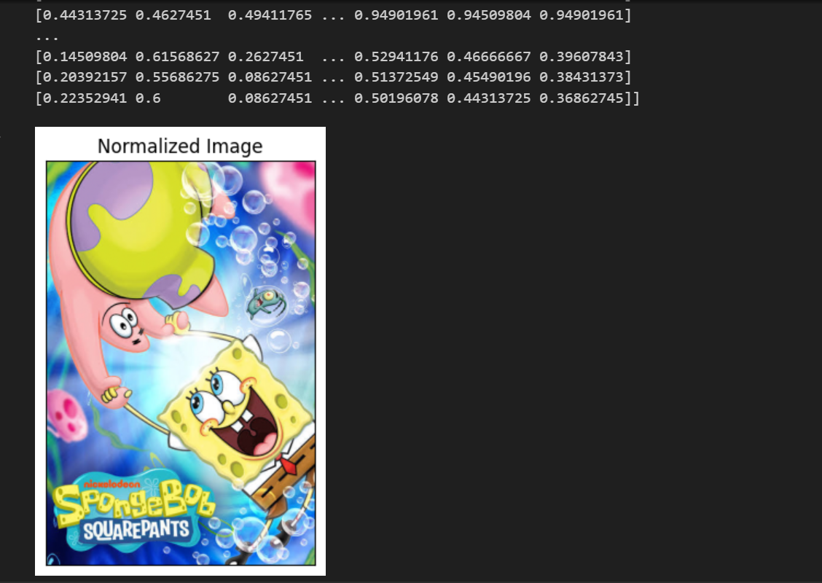

import cv2

import numpy as np

import matplotlib.pyplot as plt

img = cv2.imread('images.jpeg')

image_rgb = cv2.cvtColor(img, cv2.COLOR_BGR2RGB)

edges = cv2.Canny(image=image_rgb, threshold1=100, threshold2=700)

fig, axs = plt.subplots(1, 2, figsize=(7, 4))

axs[0].imshow(image_rgb)

axs[0].set_title('Original Image')

axs[1].imshow(edges)

axs[1].set_title('Image edges')

for ax in axs:

    ax.set_xticks([])

    ax.set_yticks([])

plt.tight_layout()

plt.show()

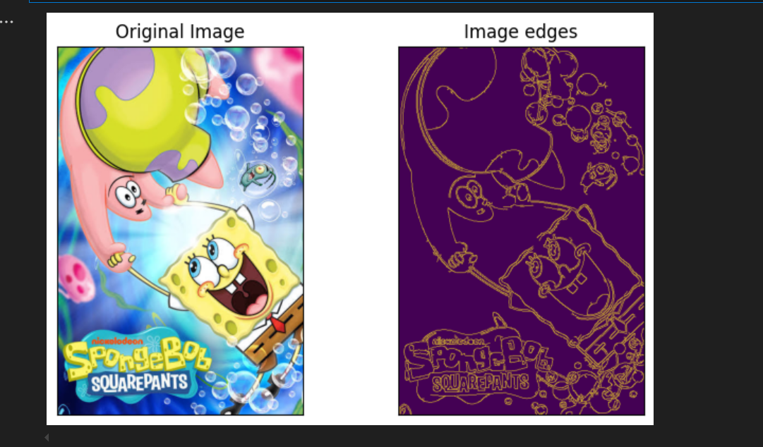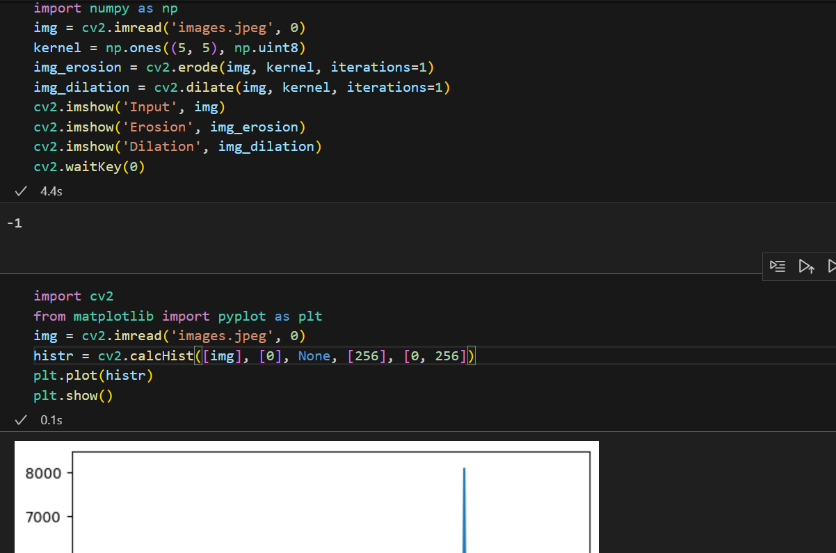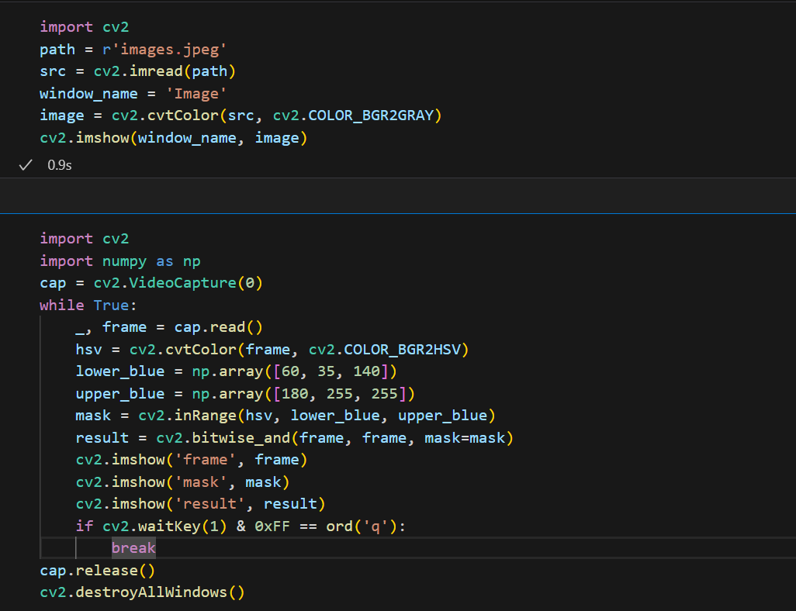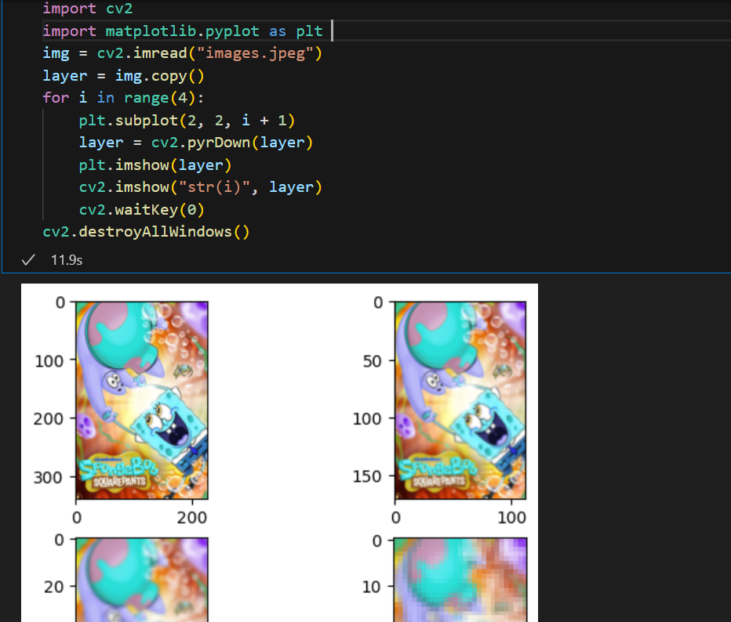

import cv2

import numpy as np

img = cv2.imread('images.jpeg', cv2.IMREAD_COLOR)

gray = cv2.cvtColor(img, cv2.COLOR_BGR2GRAY)

gray_blurred = cv2.blur(gray, (3, 3))

detected_circles = cv2.HoughCircles(gray_blurred,

                cv2.HOUGH_GRADIENT, 1, 20, param1 = 50,

            param2 = 30, minRadius = 1, maxRadius = 40)

if detected_circles is not None:

    detected_circles = np.uint16(np.around(detected_circles))

    for pt in detected_circles[0, :]:

        a, b, r = pt[0], pt[1], pt[2]

        cv2.circle(img, (a, b), r, (0, 255, 0), 2)

        cv2.circle(img, (a, b), 1, (0, 0, 255), 3)

        cv2.imshow("Detected Circle", img)

        cv2.waitKey(0)

import numpy as np

import cv2

from matplotlib import pyplot as plt

img = cv2.imread('images.jpeg')

gray = cv2.cvtColor(img, cv2.COLOR_BGR2GRAY)

corners = cv2.goodFeaturesToTrack(gray, 27, 0.01, 10)

corners = np.int0(corners)

for i in corners:

    x, y = i.ravel()

    cv2.circle(img, (x, y), 3, 255, -1)

plt.imshow(img), plt.show()

import cv2

import numpy as np

image = cv2.imread('images.jpeg', 0)

params = cv2.SimpleBlobDetector_Params()

params.filterByArea = True

params.minArea = 100

params.filterByCircularity = True

params.minCircularity = 0.9

params.filterByConvexity = True

params.minConvexity = 0.2

params.filterByInertia = True

params.minInertiaRatio = 0.01

detector = cv2.SimpleBlobDetector_create(params)

keypoints = detector.detect(image)

blank = np.zeros((1, 1))

blobs = cv2.drawKeypoints(image, keypoints, blank, (0, 0, 255), cv2.DRAW_MATCHES_FLAGS_DRAW_RICH_KEYPOINTS)

text = "Number of Circular Blobs: " + str(len(keypoints))

cv2.putText(blobs, text, (20, 550), cv2.FONT_HERSHEY_SIMPLEX, 1, (0, 100, 255), 2)

cv2.imshow("Filtering Circular Blobs Only", blobs)

cv2.waitKey(0)

cv2.destroyAllWindows()

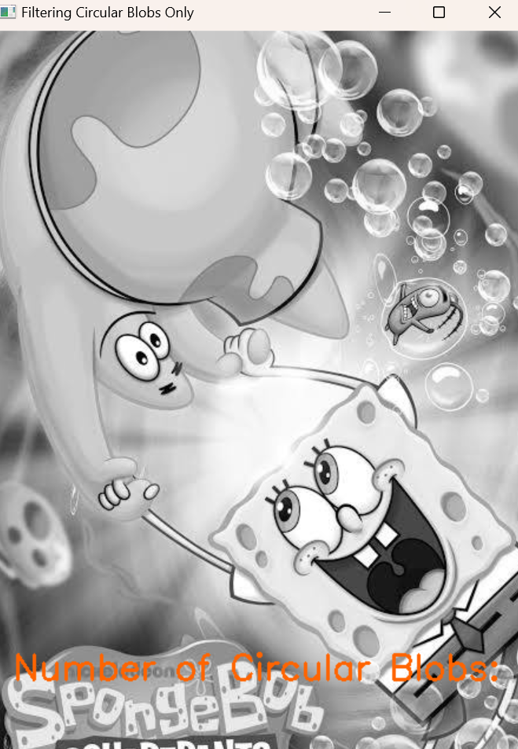

import cv2

import numpy as np

image = cv2.imread('images.jpeg')

operatedImage = cv2.cvtColor(image, cv2.COLOR_BGR2GRAY)

operatedImage = np.float32(operatedImage)

dest = cv2.cornerHarris(operatedImage, 2, 5, 0.07)

dest = cv2.dilate(dest, None)

image[dest > 0.01 * dest.max()] = [0, 0, 255]

cv2.imshow('Image with Borders', image)

if cv2.waitKey(0) & 0xFF == 27:

    cv2.destroyAllWindows()

